**What is a storyboard?**

Storyboards are graphic organizers in the form of illustrations or images displayed in sequence for the purpose of pre-visualizing a motion picture, animation, motion graphic or interactive media sequence. For our purpose, it will be used for the purpose of creating a digital video sequence.

The storyboarding process, in the form it is known today, was developed at the Walt Disney Studios during the early 1930’s, after several years of similar processes being in use at Walt Disney and other animation studios.

**Create a story board for Hangman Game.**

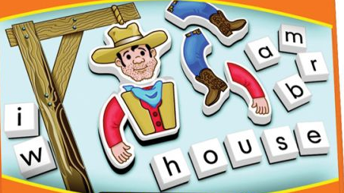

**My Story Board:**

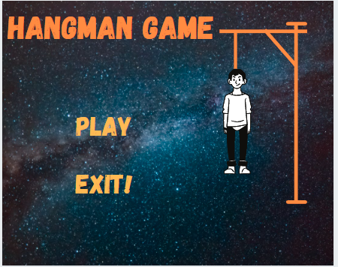

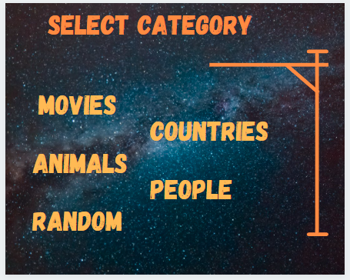

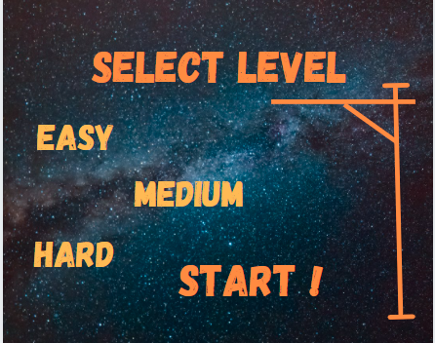

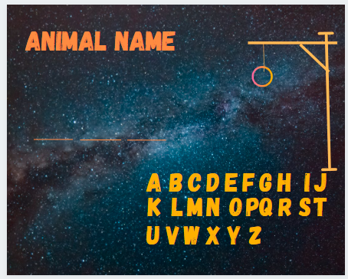

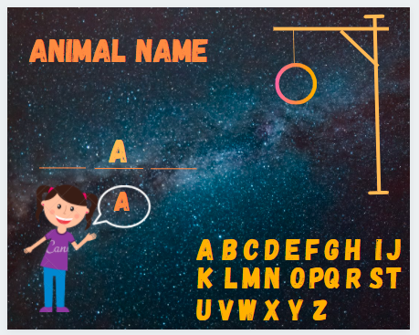

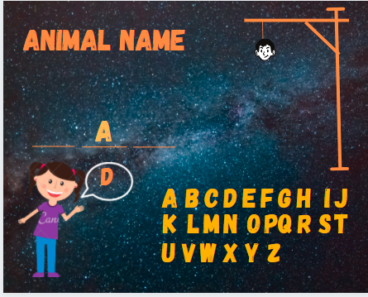

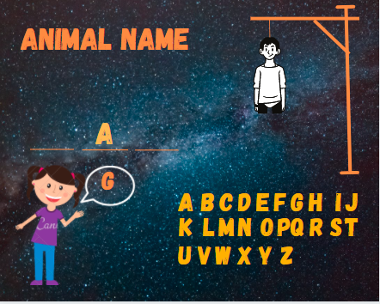

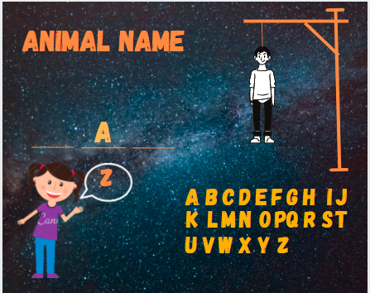

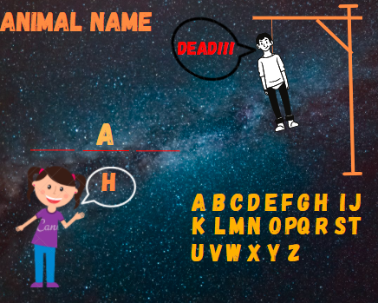

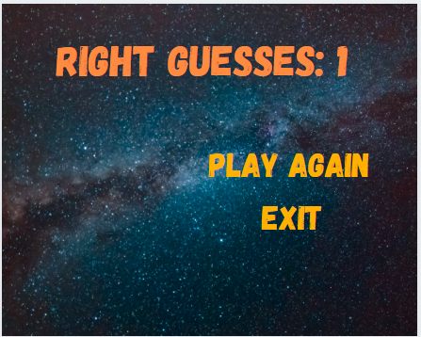

For generating storyboard following site was helpful.

<https://www.canva.com/create/storyboards/>